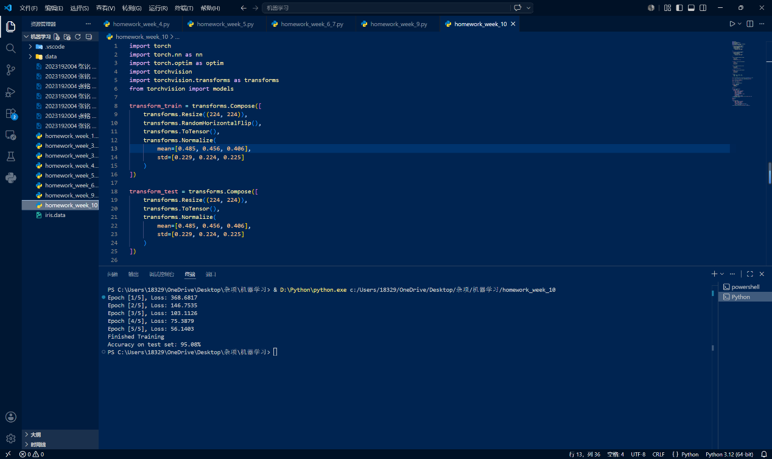
import torch
import torch.nn as nn
import torch.optim as optim
import torchvision
import torchvision.transforms as transforms
from torchvision import models

transform_train = transforms.Compose([
transforms.Resize((224, 224)),
transforms.RandomHorizontalFlip(),
transforms.ToTensor(),
transforms.Normalize(
mean=[0.485, 0.456, 0.406],
std=[0.229, 0.224, 0.225]
)
])

transform_test = transforms.Compose([
transforms.Resize((224, 224)),
transforms.ToTensor(),
transforms.Normalize(
mean=[0.485, 0.456, 0.406],
std=[0.229, 0.224, 0.225]
)
])

trainset = torchvision.datasets.CIFAR10(
root='./data',
train=True,
download=True,
transform=transform_train
)

trainloader = torch.utils.data.DataLoader(
trainset,
batch_size=64,
shuffle=True,
num_workers=0
)

testset = torchvision.datasets.CIFAR10(
root='./data',
train=False,
download=True,
transform=transform_test
)

testloader = torch.utils.data.DataLoader(
testset,
batch_size=1000,
shuffle=False,
num_workers=0
)

classes = (
'plane', 'car', 'bird', 'cat',
'deer', 'dog', 'frog', 'horse',
'ship', 'truck'
)

device = torch.device("cuda" if torch.cuda.is_available() else "cpu")

model = models.resnet18(weights=models.ResNet18_Weights.DEFAULT)

num_ftrs = model.fc.in_features
model.fc = nn.Linear(num_ftrs, 10)

model = model.to(device)

criterion = nn.CrossEntropyLoss()

optimizer = optim.SGD(
model.parameters(),
lr=0.001,
momentum=0.9
)

epochs = 5

for epoch in range(epochs):
model.train()
running_loss = 0.0
for inputs, labels in trainloader:
inputs = inputs.to(device)
labels = labels.to(device)
optimizer.zero_grad()
outputs = model(inputs)
loss = criterion(outputs, labels)
loss.backward()
optimizer.step()
running_loss += loss.item()
print(f"Epoch [{epoch+1}/{epochs}], Loss: {running_loss:.4f}")
print("Finished Training")

model.eval()
correct = 0
total = 0

with torch.no_grad():
for images, labels in testloader:
images = images.to(device)
labels = labels.to(device)
outputs = model(images)
_, predicted = torch.max(outputs.data, 1)
total += labels.size(0)
correct += (predicted == labels).sum().item()
print(f'Accuracy on test set: {100 * correct / total:.2f}%')

